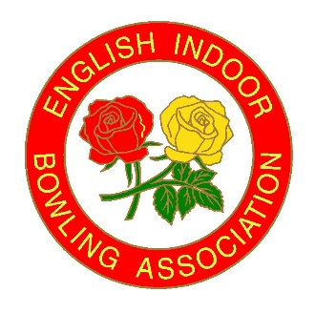
English Indoor
Bowling Association Ltd
David Cornwell House, Bowling Green,
Leicester Road. Melton Mowbray
Leicestershire LE13 0FA
Telephone: 01664 481 900
Website: www.eiba.co.uk

Dear Organiser

President Match request form

Thank you for your considering hosting a Match with our President and team to join in your Club/County’s Anniversary celebrations.

Please complete this form below by return to Sophie de Ronde, email sophiederonde@eiba.co.uk

Reason for celebration
i.e 50th Anniversary
Name of opponents
Venue to be held
Dates required:  Option A  Option B  Option C | -  -  -
Preferred start time?
How many mixed rinks?
Name of President attending:
Catering plans/ Arrangements | Tea/Coffee on arrival: YES / NO  Meal before or after the Match: YES / NO
Any charges for players?
Please state amount
Contact name
Contact email & tel. number
Please provide any relevant information relating to your celebration.

Regards
Sophie
Sophie de Ronde
Administrator
English Indoor Bowling Association Ltd

