EIBA Anti-Doping Rules
The Association’s Anti-Doping Rules are:
“The anti-doping rules of the English Indoor Bowling Association Limited are the UK Anti-Doping Rules published by UK Anti-Doping (or its successor), as amended from time to time. Such rules shall take effect and be construed as rules of the English Indoor Bowling Association Limited.”
For further guidance, the following websites are recommended for all Bowlers/Support Personnel:
The UK Anti-Doping (UKAD) website is aimed at all UK athletes. We encourage all Bowlers and Support Personnel (Club/County Officials, Umpires and Coaches) to use this website as their primary source of information when researching anti-doping:
www.ukad.org.uk/
The latest version of the EIBA Anti-Doping Rules can be found at:
www.ukad.org.uk/resources/document/uk-anti-doping-rules
The World Anti-Doping Agency (WADA) website provides general anti-doping information including the World Anti-Doping Code and the Prohibited List:
www.wada-ama.org
The Global Drug Reference Online (Global DRO) website provides Bowlers and Support Personnel with information about the prohibited status of specific substances based on the current WADA Prohibited List:
www.globaldro.com
Guidance for all Playing Members of Affiliated Clubs and County Associations and their Support Personnel
If a Bowler is taking medication they are encouraged to follow the simple procedures outlined below:
Check on the Global DRO website to see whether medication is prohibited - www.globaldro.com/UK/search
ONLINE HELP
Follow these simple steps to find the status of a brand or ingredient:
Click onto www.globaldro.com/UK/search
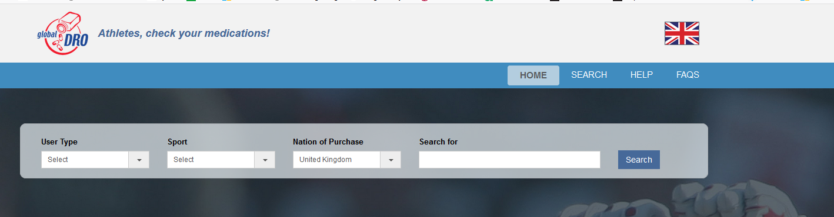Select your "User Type" (e.g., Athlete, Coach, Parent, Sports Administrator).
Select our "Sport" – Bowls
Select appropriate “Nation of Purchase”
Enter a minimum of four characters of the brand name, or the active ingredient into the “Search for” box.
Click [Search].
Read the "Terms and Conditions" carefully. Click "I accept these terms" to continue. If you choose to not accept the conditions, you will not be allowed to proceed to the search page.

Sample Search: - Seretide
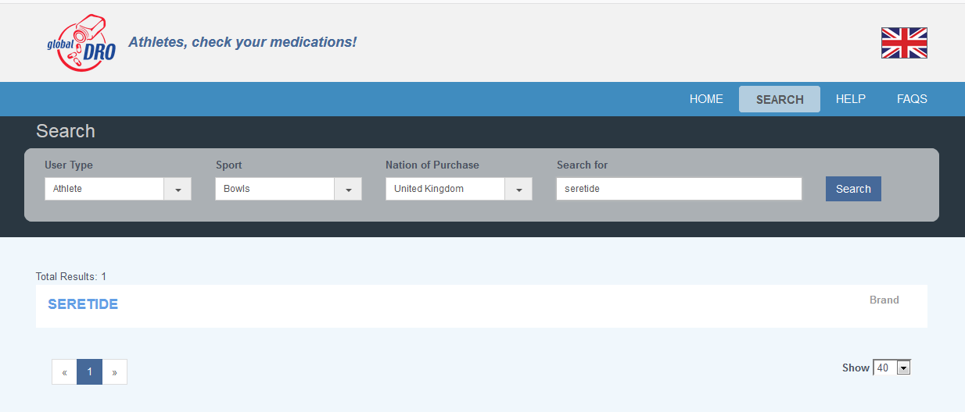

Click [View status] on the correct brand or ingredient from the list, checking that the name on the Global DRO matches that on the label. This must be an exact match.
Sample “View Status”
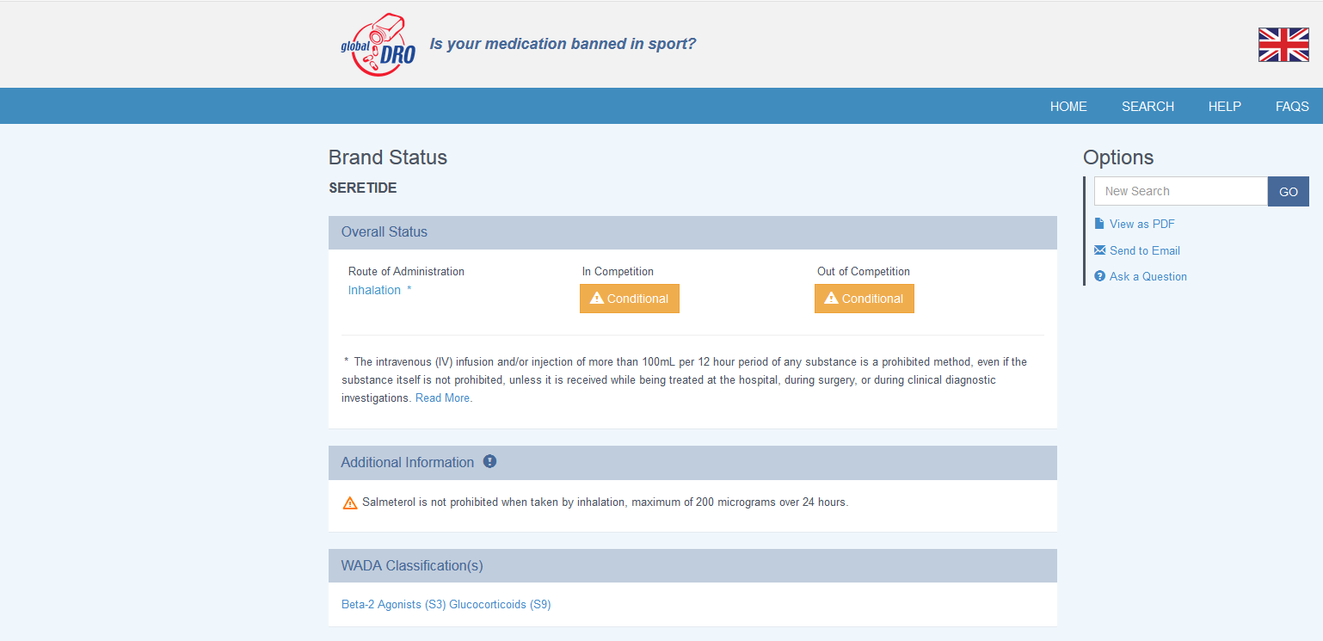
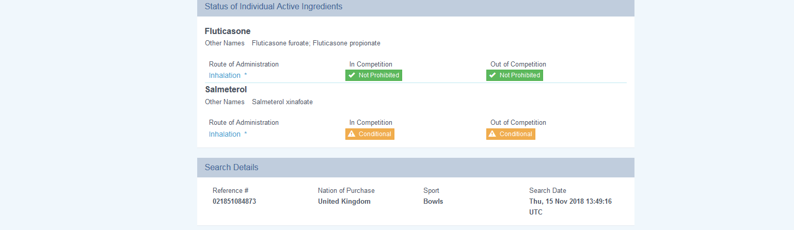
Print, save or email the summary page to keep for your records (or at minimum record the unique reference number).
Important information about search results:
- Always record your reference number!
- The in- and out-of-competition status will be shown for each ingredient contained in the brand.
- For brands containing multiple ingredients, always refer to the overall status listed at the top of the results page.
- Caution: Do not use the Global DRO to check supplement ingredients. See the FAQ for more information about the results of the Search - www.globaldro.com/UK/search/FAQ
- Ingredients and brands will be displayed as:
No action is required apart from printing or emailing the result to the Bowler/Support Personnel’s email address for future reference.

Consider the “Additional Information” that is provided. If you meet these conditions, then the Medication is “Not Prohibited”.
If you DO NOT meet the conditions, please treat the Medication as being “Prohibited”

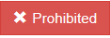 ACTION REQUIRED:
The Bowler should speak with their doctor to see if alternative medication is available.

If this is not an option:
  - If the Bowler is a member of the “Indoor Bowls National Registered Testing Pool” or “Indoor Bowls Domestic Pool”, they will be required to obtain a Therapeutic Use Exemption (TUE) in advance of their participation in our sport.
Bowlers will be advised when they have been included in a testing pool.
  - If the Bowler is not a member of a testing pool, if necessary, they can apply for a retrospective TUE after sample collection has taken place.

Full details of the TUE procedures can be found at https://ukad.org.uk/medications-and-substances/about-TUE/

PLEASE NOTE that the onus is now on all Bowlers to check their medication. It is no longer necessary to complete a “Medical Declaration Form” or carry a copy of their latest Prescription, as have been the practices in the past.

All Bowlers/Support Personnel should also note the following websites:

World Anti-Doping Agency Prohibited List
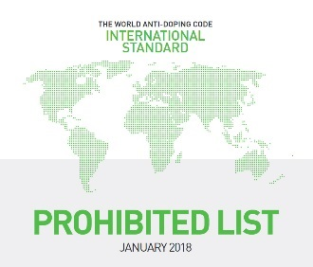 | Prohibited List  The Prohibited List is published every year by the World Anti-Doping Agency (WADA). . | www.wada-ama.org/en/content/what-is-prohibited

100% me
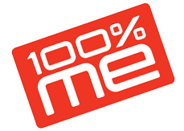 | 100% me  100% me is a values based programme that informs, supports and educates athletes throughout their careers by providing practical anti-doping advice and guidance to ensure they are aware of the risks and responsibilities associated with anti-doping in sport. | www.ukad.org.uk/education/athletes/100percentme/

EIBA Contact Details if you require any further information
EIBA Headquarters – Tel: 01664 481900
Chief Operating Executive – Peter Thompson e-mail: PeterThompson@eiba.co.uk Mobile: 07852 282998
Development Manager – Stephen Rodwell e-mail: SteveR@eiba.co.uk Mobile: 07831 284748

Updated November 2018

Disclaimer - Every effort has been made to ensure the accuracy of the information contained in this guidance note. The English Indoor Bowling Association Ltd (EIBA), its servants or agents shall not at any time, in any circumstances, be held responsible or liable to any party in respect of any loss, damage or costs of any nature arising directly or indirectly from reliance placed on the material in this guidance note, or any other guidance notes issued by the EIBA This information has been prepared as a basic guide only and should not be viewed as a substitute for obtaining comprehensive expert or professional advice.

