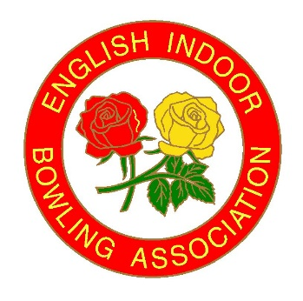
English Indoor

Bowling Association Ltd
David Cornwell House, Bowling Green, Form D
Leicester Road. Melton Mowbray
Leicestershire LE13 0FA
Telephone: 01664 481 900
Email: carlhiggins@eiba.co.uk Website: www.eiba.co.uk

General Enquiries: enquiries@eiba.co.uk

CHAMPION OF CHAMPIONS 2025/2026

CLUB ………………………………………………………………………………………………………

MEN’S CLUB CHAMPION WOMEN’S CLUB CHAMPION

NAME…………………………………………………………………………

ADDRESS………………………………………………………………….

………………………………………………………………………………….

CONTACT NUMBER………………………………………………….

EMAIL ADDRESS …………………………………………………….
If no email address, please provide postal address above

PLEASE NOTE: If you are unable to give the name of your club champion at the time of entry please tick box and add Champion to be advised.

----------------------------------------------------------------------------------------------
Permission to publish data is required from the Named Entrant who will be our contact for this competition. For ease of communication please ensure that email addresses are included on this form. Details regarding the use of Personal Data in line with GDPR can be found overleaf.
COMPETITION NAME | NAMED ENTRANT | EMAIL ADDRESS | CONTACT NUMBER | SIGNATURE | Date
Champion of Champion |  | If no email address, please insert postal address |  | I hereby consent to the use of this personal data as outlined overleaf. (If Under 18 Parent/Guardian Signature required- see below)
 |  |  |  | SIGNATURE
 |  |  |  | Print Parent/Guardian Name

Under 18s
If you are under the age of eighteen when the competition takes place, we will require consent from your parent/guardian to use your personal data as outlined overleaf. Please arrange for your parent/guardian to sign above or they can email their authority to us indicating their approval for use of your personal data.

PTO
We will publish your Personal data and use as follows:
- All stages of the Champion of Champions and every season thereafter.
Personal Data | Use of Data
Name  Club Name – For Information | EIBA website/social media - public access  EIBA Finals Programme – public access  EIBA Yearbook – Public Access  EIBA Promotional/Marketing Material – Public Access
Name, contact number, email address/postal address  Club Name – For Information | EIBA Database and Competition System -  for access by EIBA Staff.  Date of Birth only required for age related competitions.
Personal Images | EIBA website/social media - public access  EIBA Finals Programme – public access  EIBA Yearbook – public access  EIBA Promotional/Marketing Material – Public Access  EIBA Facebook Live Streaming/Videoing – Public Access

By signing this form, you are consenting to the use of this data for the purposes outlined above. Your Club will provide you with a copy of this “guidance” for your retention upon request.

Full details of the EIBA Privacy Notice can be downloaded at www.eiba.co.uk/privacy/privacy-notice.pdf or printed copies are available from EIBA Headquarters at Melton Mowbray.

If you have any questions relating to GDPR and/or if you wish to withdraw/amend your consent please contact Stephen Rodwell (EIBA Data Protection Manager) email: SteveRodwell@eiba.co.uk or Tel: 01664 481900 or via post to David Cornwell House, Bowling Green, Leicester Road, Melton Mowbray, Leics, LE13 0FA.

