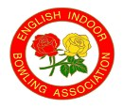ENGLISH INDOOR BOWLING ASSOCIATION LTD
County Association
MEN’S WINTER NATIONAL CHAMPIONSHIP ENTRIES 2025-2026
ENTRY FORM & GENERAL DATA PROTECTION REGULATION FORM FOR NAMED ENTRANTS
Men’s County Competitions – Liberty Trophy, Under 25 Open Inter-County Double Rink, 060 Inter- County and Under 18 Open Two Rink Triples
Permission to publish data is required from all Named Entrants who will be our contact for all competitions. For ease of communication please ensure that email addresses are included on this form. Details regarding the use of Personal Data in line with GDPR can be found overleaf.
COMPETITION NAME | NAMED ENTRANT | EMAIL ADDRESS –  If no email address, please insert postal address | CONTACT NUMBER | SIGNATURE | DATE
Liberty Trophy |  |  |  | I hereby consent to the use of this personal data as outlined overleaf.
 |  |  |  | SIGNATURE
Under 25 Open Inter-County Double Rink |  |  |  | I hereby consent to the use of this personal data as outlined overleaf.
 |  |  |  | SIGNATURE
O60 Inter- County |  |  |  | I hereby consent to the use of this personal data as outlined overleaf.
 |  |  |  | SIGNATURE
Under 18 Open Two Rink Triples |  |  |  | I hereby consent to the use of this personal data as outlined overleaf.  (Entrant’s Parent/Guardian Signature)*
 |  |  |  | SIGNATURE
 |  |  |  | Print Parent/Guardian Name

Under 18s
If you are under the age of eighteen when the competition takes place, we will require consent from your parent/guardian to use your personal data as outlined overleaf. Please arrange for your parent/guardian to sign above or they can email their authority to us indicating their approval for use of your personal data.
COUNTY COMPETITION | VAT
Liberty Trophy | exempt | £120.00
Under 25 Open Inter-County Double Rink | exempt | £40.00
O60 Inter-County | exempt | £120.00
Under 18 Open Two Rink Triples | exempt | £30.00

TOTAL
Name of County….............................................. Signed by County Secretary/Treasurer ……………………………………
Print Name .................................... Date payment is made by Club to the EIBA Bank Account….....................
Methods of payment - please tick method used
□ By cheque made payable to English Indoor Bowling Association Ltd
□ Direct to bank - sort code 20-99-40 Account no. 93531465 - quote county name as reference
PLEASE RETURN BY POST TO DAVID CORNWELL HOUSE, BOWLING GREEN, LEICESTER RD, MELTON MOWBRAY LE13 0FA or send by email to carlhiggins@eiba.co.uk ENTRY AND PAYMENT TO BE RECEIVED BY
8th June 2025

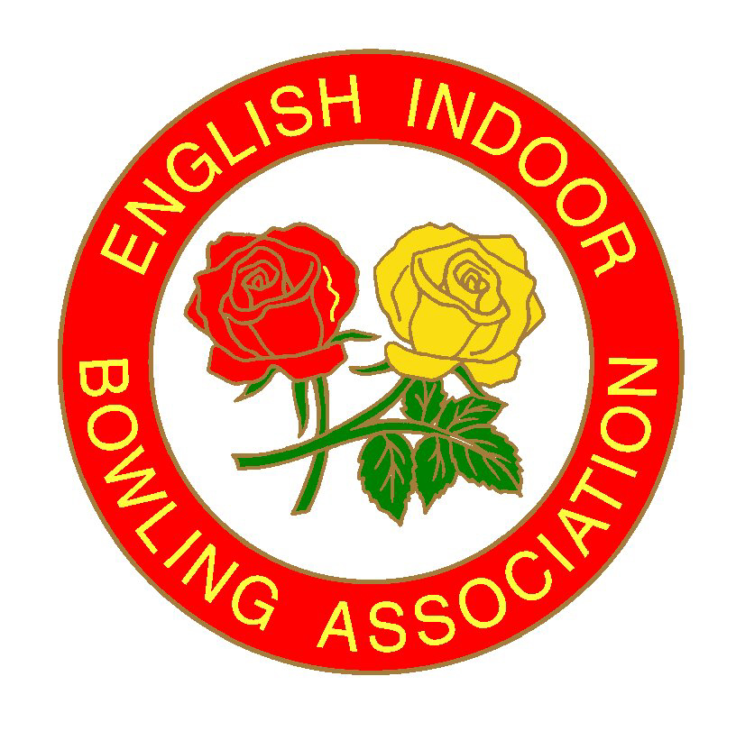English Indoor

Bowling Association Ltd

David Cornwell House, Bowling Green,
Leicester Road. Melton Mowbray
Leicestershire LE13 0FA
Telephone: 01664 481 900

Email: carlhiggins@eiba.co.uk Website: www.eiba.co.uk

INFORMATION FOR NAMED ENTRANT

To comply with the General Data Protection Regulation (GDPR) rules relating to the collection and use of “Personal Data” it is necessary for us to obtain the Consent of all “Named Entrants” to the EIBA National Competitions, so that we can publish and process your data, as provided to us by your County as part of the overall EIBA Competition Administration System.
The “Named Entrant” is defined as: The person entering an EIBA National Competition on behalf of themselves and a team and all communication from the EIBA will be to the named entrant.
We will publish your Personal data and use as follows:
Personal Data | Use of Data
Name, contact number, email address/postal address  Club Name – For Information  Personal Image | Competition Team Draw Books -  for distribution to all Counties with entries in any of the Men’s or Ladies National County Competitions. Area Co-ordinator, EIBA Board and EIBA Staff.  EIBA website/social media  for access by Area Competition Co-ordinator and EIBA Staff  EIBA Promotional/Marketing Material
Name, contact number, email address/postal address  Club Name – For Information | EIBA Database and Competition System -  for access by EIBA Staff and distribution County Correspondent for updating.
By signing the Mens County Competition Form, you are consenting to the use of this data for the purposes outlined above. Your Club will provide you with a copy of this “guidance” for your retention upon request. Your Named Entrant data will be used for
- All competitions entered for the 2025/2026 year and for each year thereafter.
- Final stages of any EIBA National Championship for the 2025/2026 year and for each year thereafter.
If you and your team reach the “Final Stages” of the National Competitions, we will then contact you to obtain Consent from your Team Members (if applicable), so that we can publish your Personal Data as follows:

For Information
You and your team’s data will be used for the following:

- Final stages of any EIBA National Championships for the 2025/2026 year and each year thereafter.
Personal Data | Use of Data
All Team names  County name – For Information | EIBA Website/social media - public access  EIBA Finals Programme – public access  EIBA Yearbook – public access  EIBA Promotional/Marketing Material
Personal Images | EIBA Website/social media - public access  EIBA Finals Programme – public access  EIBA Yearbook – public access  EIBA Promotional/Marketing Material – public access  EIBA Approved - Live Streaming/Videoing/Television Broadcast – public access

Full details of the EIBA Privacy Notice can be downloaded at www.eiba.co.uk/privacy/privacy-notice.pdf. or printed copies are available from EIBA Headquarters at Melton Mowbray.

If you have any questions relating to this request for consent, please contact: Carl Higgins email: carlhiggins@eiba.co.uk or Tel: 01664 481900.

If you have any questions relating to GDPR and/or if you wish to withdraw/amend your consent please contact Stephen Rodwell (EIBA Data Protection Manager) email: SteveRodwell@eiba.co.uk or Tel: 01664 481900 or via post to David Cornwell House, Bowling Green, Leicester Road, Melton Mowbray, Leics, LE13 0FA.

