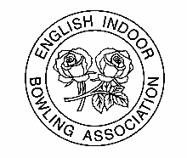
English Indoor Bowling Association Ltd

PLEASE SPECIFY CLUB/COUNTY: BIIBC U18’s International Series 2019

Trials to be held on Sunday 28th April 2019 at Rugby Thornfield, Bruce Williams Way, Rugby, Warks, CV22 5LL (download)

Players Details | DOB | Club U18 Champion | EBYDS Finalist | U25 Club  Double Rink | U25 County Double Rink | EIBA National Championship Events | EIBA Skills Award level (bronze, silver or gold) | Preferred playing position
 |  | Please indicate year | Please indicate year | Please indicate year and playing position | Please indicate year and playing position | Please indicate name of Championship and achievements | Please indicate | Please indicate
Name

Address

Email
Parents e-mail address if possible

Name

Address

Email
Parents e-mail address if possible

Name

Address

Email
Parents e-mail address if possible

Name: ____________________________ Position held within the Club: _______________________ i.e Club Secretary

Signed: _____________________ Date: _______________________

Please return to joanneshore@eiba.co.uk or English Indoor Bowling Association Limited, David Cornwell House, Bowling Green, Melton Mowbray, Leicestershire LE13 0FA

