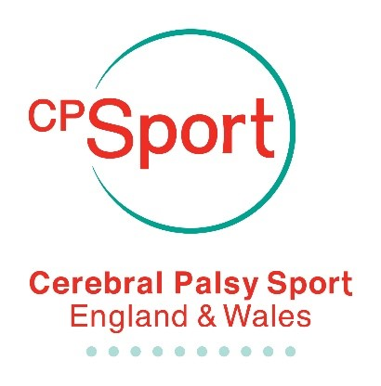
CP Sport Registration Form

Event: BowlStart Cumbria
Participant Details:
Mr Mrs Ms Miss Other
Full Name:
Address:

Post Code:
Tel No.:
Date of Birth:
Age:
Email:
CP Sport Membership No.:
Parent / Guardian / Emergency Contact:
Mr Mrs Ms Miss Other
First Name:
Surname:
Emergency phone no:
Email:
How did you find out about this event?

Medical Details:
Do you have cerebral palsy? Yes No
Please indicate if you have any medical conditions or any other special requirements we should be aware of e.g. asthma, allergies.
Mobility:
Ambulant Frame Cane/Crutches
Wheel Chair Power Chair

I give permission for the named participant to take part in this CP Sport event. In the event of an accident or emergency, I give permission for any immediate treatment deemed necessary by a qualified first aider/medical practitioner.

Would you like to receive regular e-mail updates through our CP Sport newsletter?
Yes No

Participant signature
(parent/guardian if under 18 years)

Date:

Event: Lincoln BowlStart Cost: £3
Membership details
Why not take advantage of our membership scheme?
Already a member – Enter Membership Number ______________________
To benefit from CP sport members discount I wish to apply for: (please √ appropriate box)
Annual Membership – Adult Member £15
Annual Membership – Junior Member (19 yrs and under) £10
Payment should accompany the application form (please tick you selected method of payment)
- I wish to pay by BACS transfer:

For payments by BACS please enter your Surname as the payment reference. Please transfer the correct amount to:
Account Name: C P SPORT Sort Code: 30-95-42 Account Number: 58689468 Name of Bank: Lloyds

- I wish to pay by Credit/ Debit card (there will be a 2.4% surcharge on all payments by credit card)

Card Type: Credit / Debit (delete as appropriate) Card Number:

Card Start Date: _ _ / _ _ Card End Date: _ _ / _ _ Issue Number (Switch card only): _ _

Card Security Number: (last 3 digits on signature strip)

Cardholder’s name and contact details (if different from participant name above):
Name: ………………………………………......... Address: …………………………………………………
………………………………………………………………………...... Post Code: ……………………………
Email: …………………………………………………………………. Telephone: ……………………………
Signature: ……………………………………………………………. Date: ……………………………………

Donations
Cerebral Palsy Sport relies on the kindness of people like you to help fund a programme of sporting events and activities for children, young people and adults with cerebral palsy. If you would like to make a donation to support more people with cerebral palsy to reach their potential through sport please tick box and state amount you would like to donate. Thank you.
I would like to help by donating £…………… to Cerebral Palsy Sport. I understand that I must have paid or will pay an amount of Income Tax and/or Capital Gains Tax in each tax year, that is at least equal to the tax that Charities & Community Amateur Sports Clubs (CASCs) I donate to will reclaim on my gifts. I understand that other taxes such as VAT and Council Tax do not qualify and that CP Sport will reclaim 25p of tax on every £1 that I give. If a UK taxpayer please tick here.

