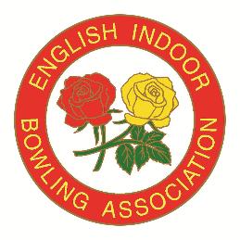
ENGLISH BOWLS YOUTH DEVELOPMENT SCHEME
COUNTY SCHOOL OF EXCELLENCE 2024/25

County entry forms to returned to the office by 1st November 2024

PLEASE NOTE THAT THE EVENT IS ONLY OPEN TO PARTICIPANTS WHOSE
AGE IS BETWEEN 8 – 18 YEARS ON OR BY 30TH SEPTEMBER 2024

The competition will be run in two sections: -

Juniors who have attained the age of 8 years but not 14 years on or by 30th September 2024
Seniors who have attained the age of 14 years but not 18 years on or by 30th September 2024

County: | Event Date:
Venue: | Number of Competitors:
Name of Co-ordinator: | Email:
Address:

Postcode: | Tel No:
We would require a small grant (if available) to host the event: | YES / NO (please delete as appropriate)

General Data Protection Regulations
To comply with the new General Data Protection Regulations (GDPR) which came into force in 2018, it is now necessary for us to obtain the consent of all “County Co-ordinators” for the Competition, so that we can process their data, as outlined below.
Personal Data | Use of Data
Name:  Telephone Number:  Email: | EIBA Database - for access by EIBA Staff.  EIBA website/Social Media - public access  EIBA Yearbook – public access  EIBA Promotional/ Marketing Material – public access
By signing this form, I hereby give consent to the use of my personal data as outlined above. | Please sign here:  Date:

Full details of the EIBA Privacy notice can be downloaded at www.eiba.co.uk/privacy/privacy-notice.pdf or printed copies are available from the EIBA Headquarters at Melton Mowbray.

If you have any questions relating to this request for consent, please contact Peter Thompson, email: peterthompson@eiba.co.uk or Tel: 01664 481900

If you have any questions relating to GDPR and/or wish to withdraw/amend your consent, please contact Stephen Rodwell (EIBA Data Protection Manager) Email: steverodwell@eiba.co.uk or Tel: 01664 481900 or via post to: EIBA Ltd, David Cornwell House, Bowling Green, Leicester Road, Melton Mowbray, Leicestershire, LE13 0FA.

